Objective: repurpose the documentation from the OTG (Open-Touch Glove) website to design a custom geometry for Bicep, Forearm and Chest pads
- How does the circuit work?
Fundamentally, the force sensing mesh is split into a number of localised points where pressure is measured. The pressure is measured using velostatic material: which is piezo resistive hence changes resistance which axial compression.
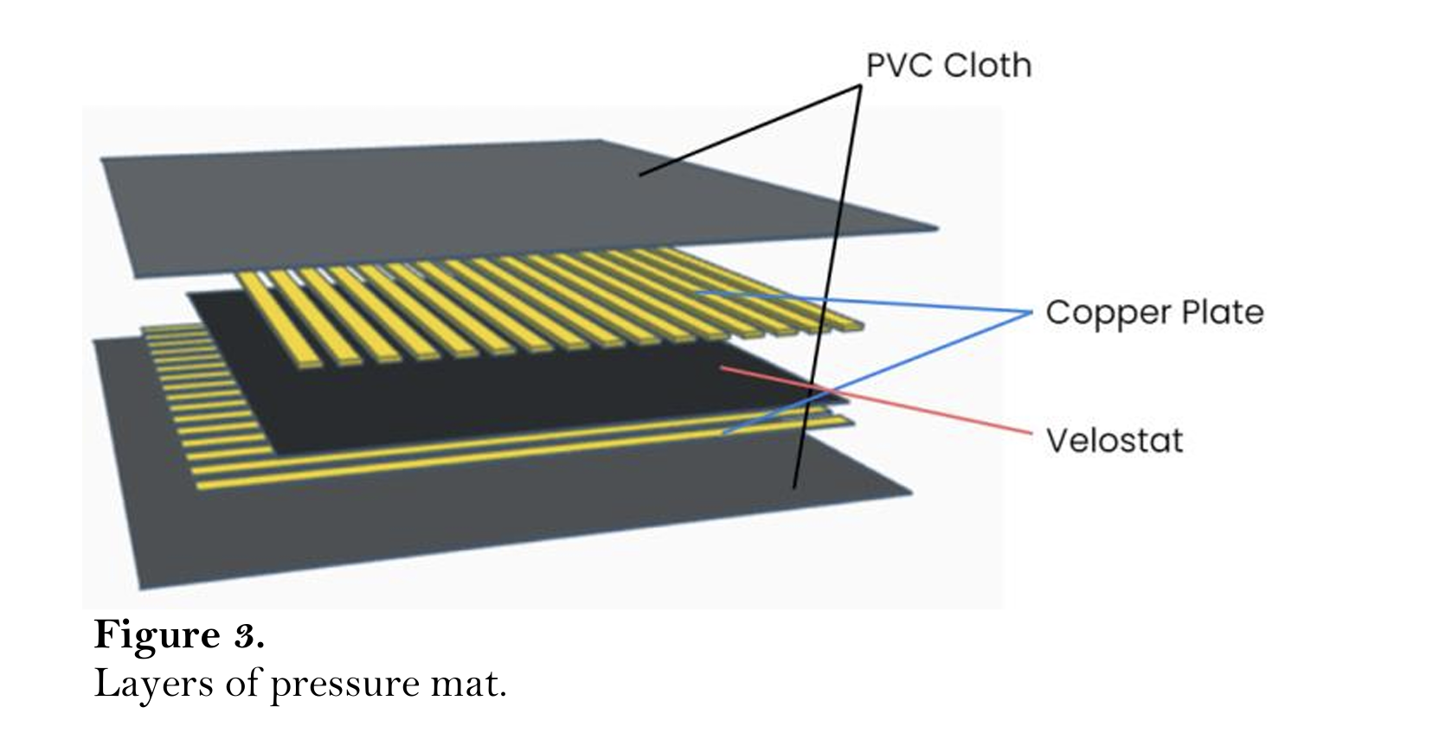
Figure 1: Design and development of an intelligent real-time pressure sensing system for sitting posture monitoring | Edelweiss Applied Science and Technology

Therefore, we can create a system of pressure points by creating a grid of ‘resistors’. Where are these resistors? In mesh of horizontal running and vertical running copper traces, the regions where they overlap are where ‘measurements’ can be taken. Because the overlaps can only be a any unique combination of 16 x 16 pins, the change in voltage at those unique pin combinations allows us to detect which location and how much pressure has been applied.
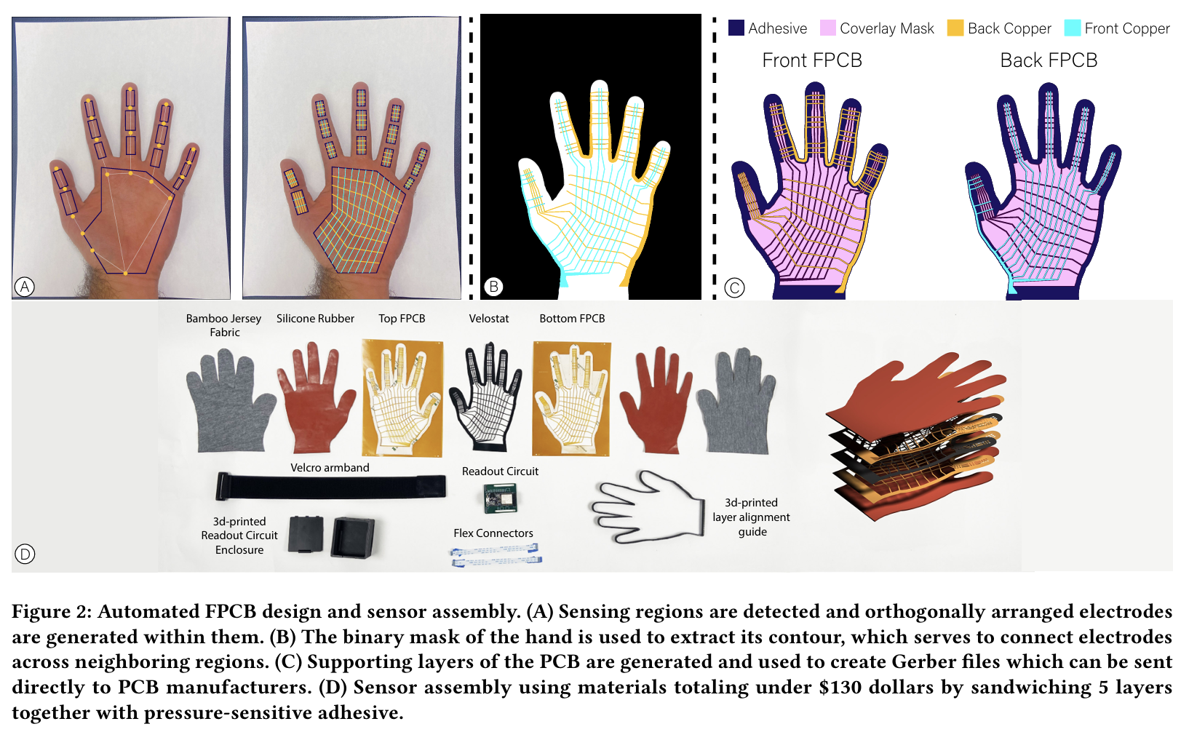

Figure 2: https://dl.acm.org/doi/epdf/10.1145/3706599.3720147

- Flex PCB Creation:
  - How is the circuit created?
The make_fpcbs.ipynb from https://github.com/devinmur29/fpcb-glove-design is the script used to detect hand contours and rescale from an image, with an A4 paper as the background reference. 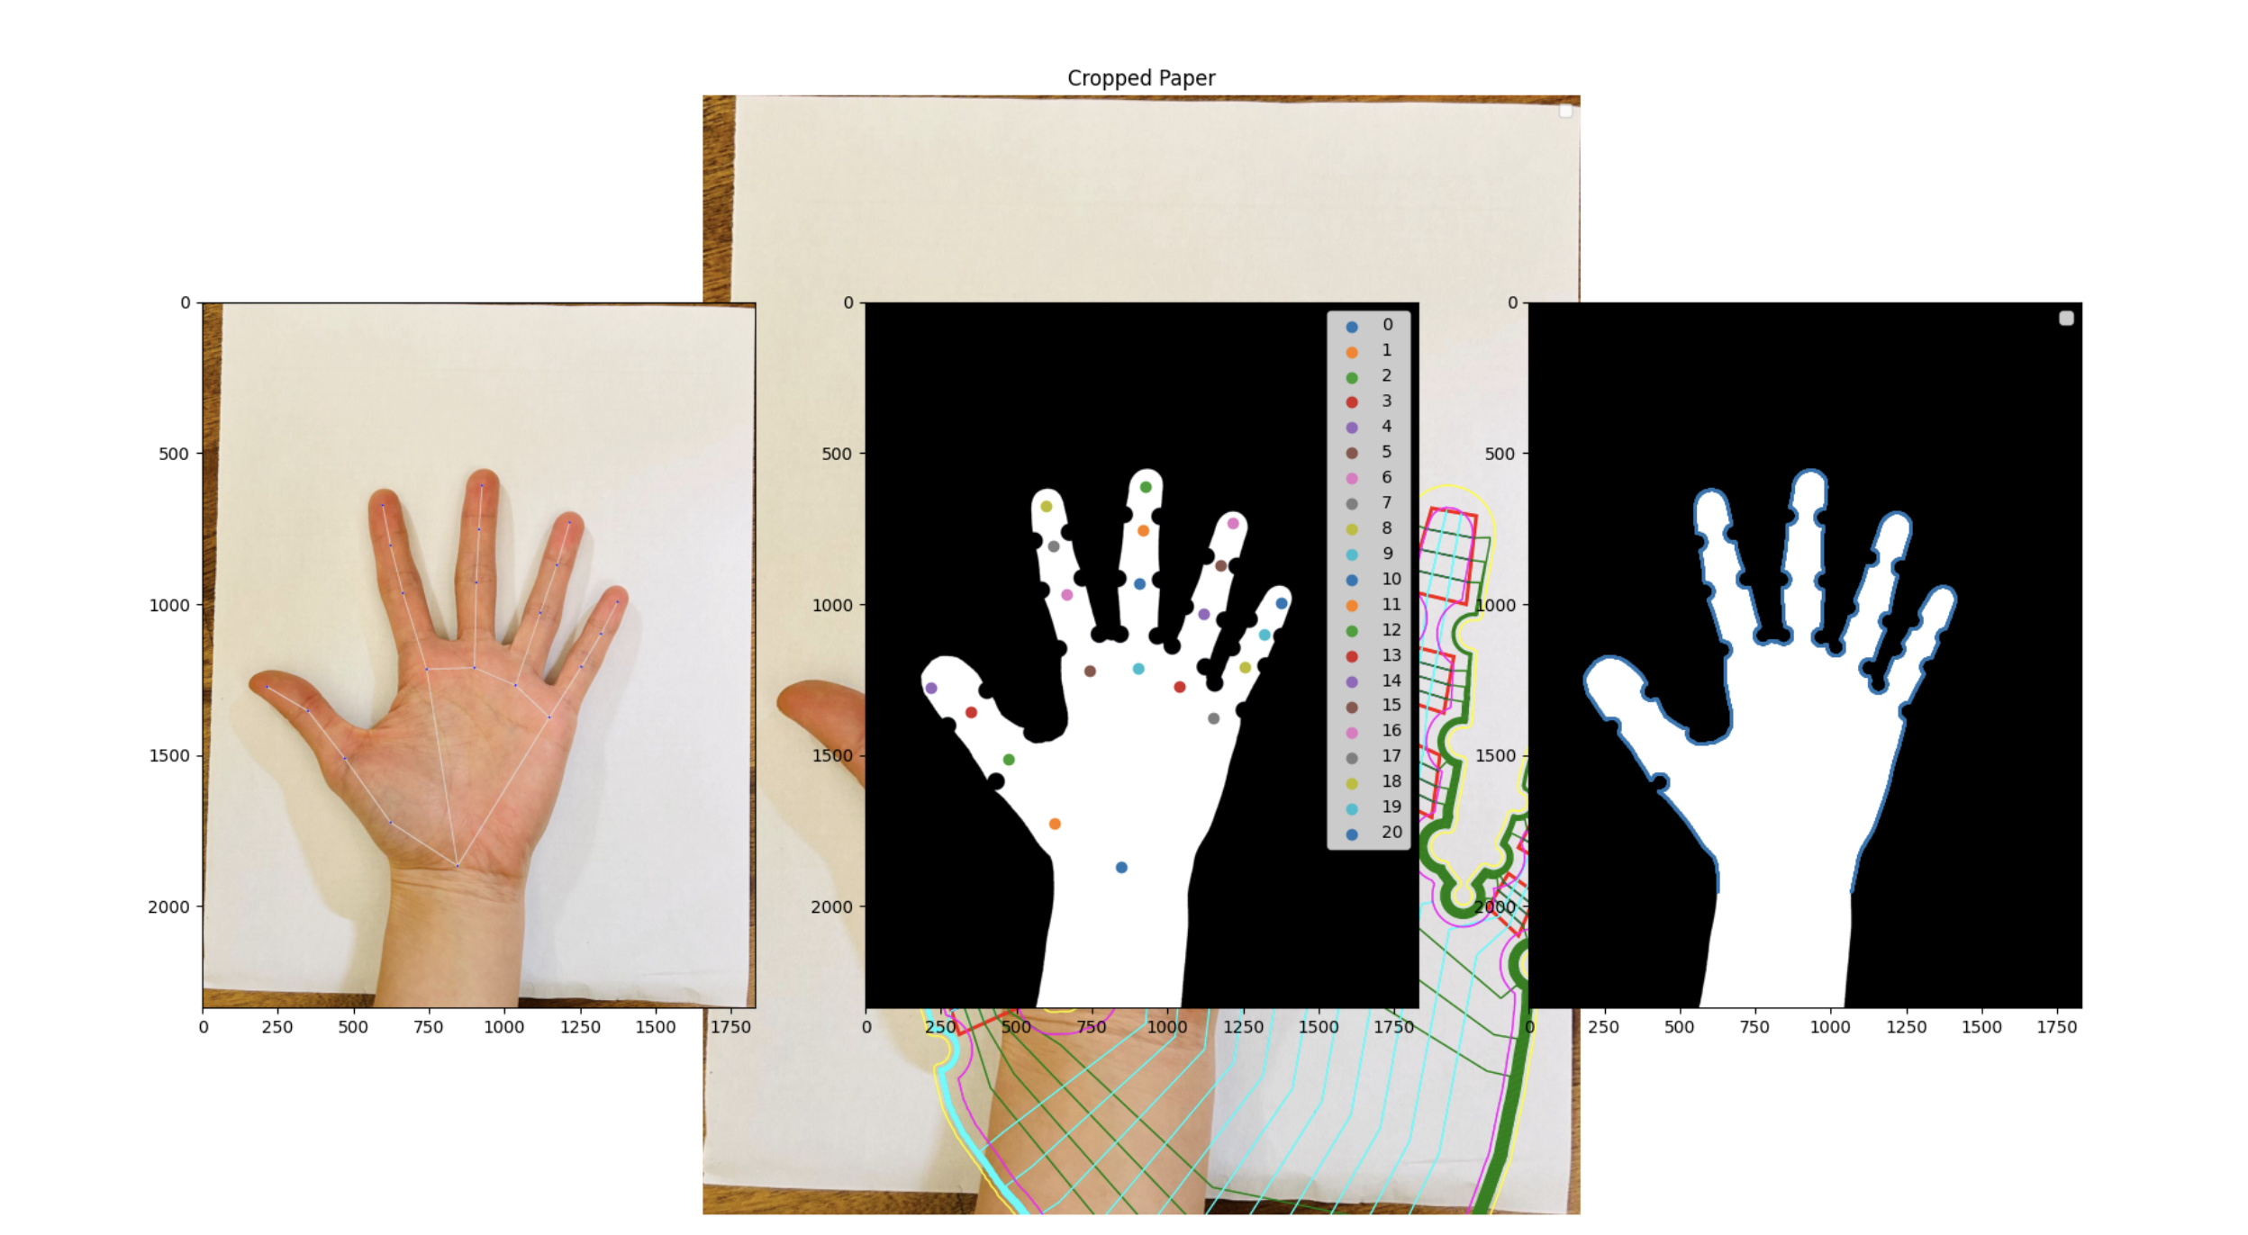
Figure 3: From the repo https://github.com/devinmur29/fpcb-glove-design
The program is then able to generate the .svg files with the relevant line contours to be able to create the diagram that the script will use to generate a KiCAD gerber file.
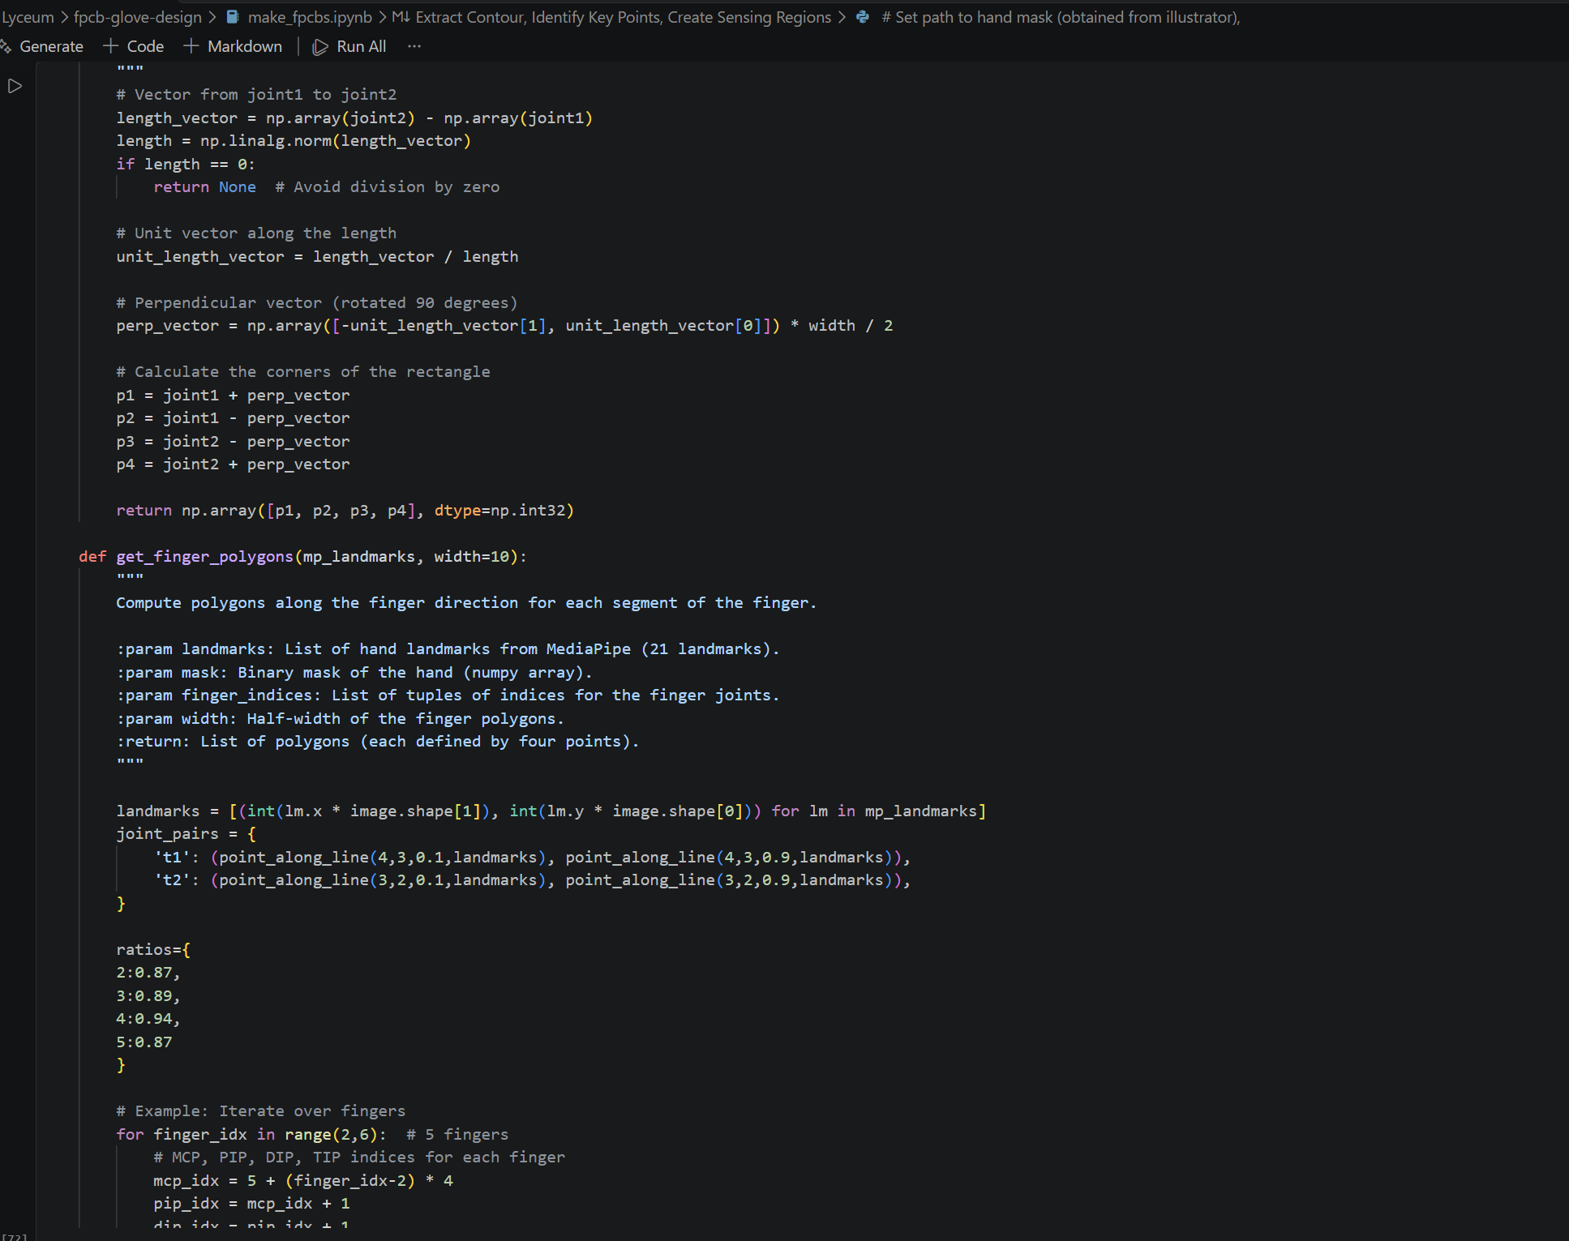
Figure 4: Code screen snippet from the repo.
Using the sensing points, the outer geometry and contours, the script automatically generates the required geometry files for the KiCAD gerber generation. Below is a description of the function of each of the layers:
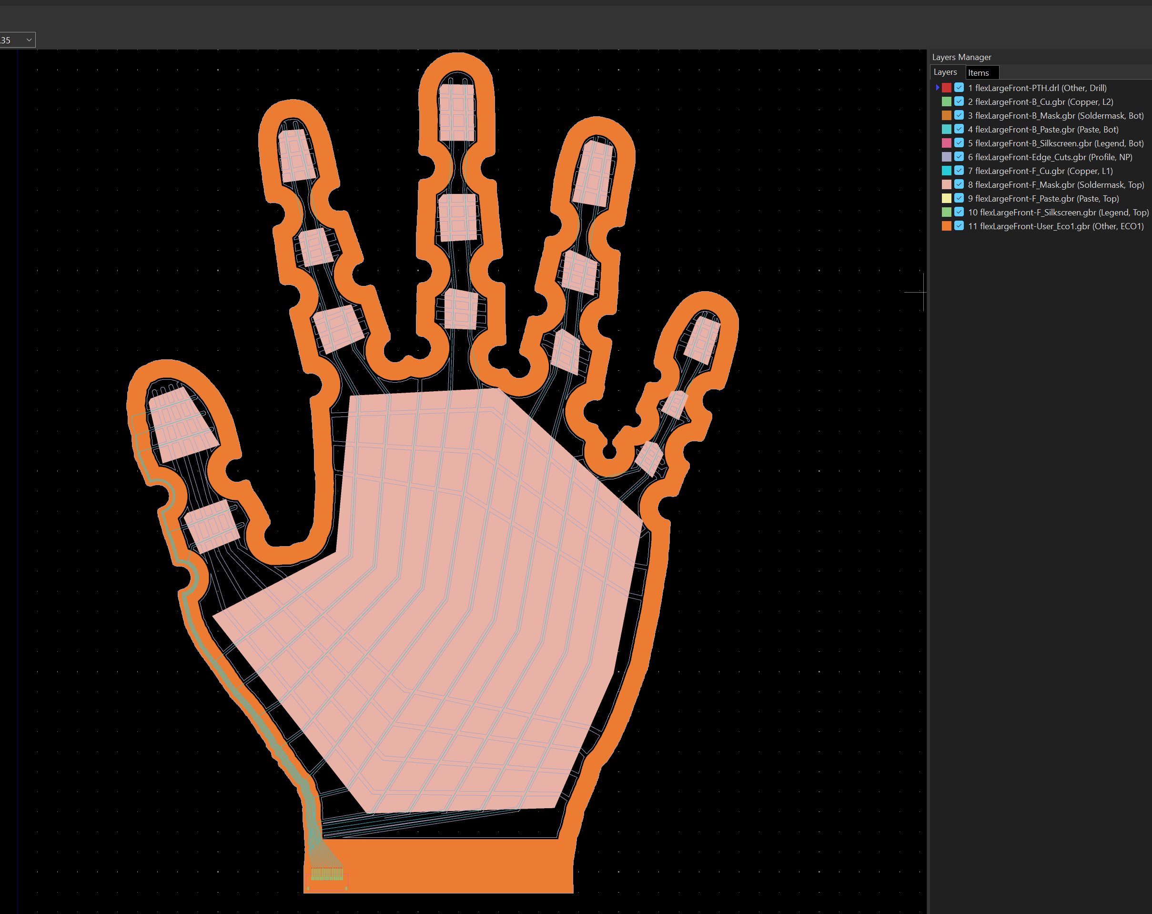
Figure 5: KiCAD screenshot of the ‘Large’ glove back layer file.
It should be noted that all of his is manufactured ona flexible Polyimide base for the flex PCB. The glove design paper also includes various additional considerations such as surface finish, copper finish and processing which all contributes to both functionality and flexibility of the PCBs.
# | File | Meaning (standard Gerber role) | What it holds here | In your screenshot
1 | PTH.drl | Plated drill holes | 16 × 0.15 mm via holes, connector tail only | Red — tiny, outside your crop
2 | B_Cu.gbr | Bottom copper (L2) | Via pads + connector pads + short fan-out | Green — connector tail only
3 | B_Mask.gbr | Bottom coverlay openings (negative: drawn = removed) | 34 openings over those pads | Orange swatch, but its geometry is only at the tail — the big orange band is not this layer
4 | B_Paste.gbr | Solder paste stencil | 18 apertures for the FFC connector (PCBWay assembles it on this side) | Teal, tail only
5 | B_Silkscreen.gbr | Legend | Connector outline | Pink, tail only
6 | Edge_Cuts.gbr | Board profile — where the laser cuts | Outer hand contour plus 239 interior slits. Per the paper: traces extruded outward 0.5 mm and subtracted from the coverlay area, so the board becomes a web of strips “to enhance flexibility and dexterity” | The fine white/grey lattice across the palm and the ladder bars on the fingers. It looks like a sensing mesh but it’s cut lines — the gaps between copper-carrying strips
7 | F_Cu.gbr | Front copper (L1) | The 16 traces: horizontal electrode bars in each sensing region + routing along the contour down to the connector | The doubled cyan lines — each trace is a filled polygon and GerbView is showing its two borders
8 | F_Mask.gbr | Front coverlay openings (negative) | 15 openings: one per finger/thumb sensing patch + one large palm polygon + the via row. Where coverlay is absent, bare copper touches the Velostat — this defines the active sensing area | Unchecked (box 8) in your view, so invisible
9–10 | F_Paste, F_Silkscreen | Paste / legend, front | Empty — no components on the sensing side | Nothing
11 | User_Eco1.gbr | Normally “engineering comments”; repurposed here as the adhesive deposit area | One band between the outer contour and the coverlay mask | The thick filled orange band hugging the whole outline
– | NPTH.drl | Non-plated holes | Empty | –
– | job.gbrjob | Stackup/metadata for the fab | Lists all of the above, “Finish: None” | –
  - How do I make sure I have the right manufacturing settings?
The design paper has already done a study on the various material parameters which affects the performance of the flex PCBs. Rolled annealed copper was the best option, but this was also compared against other options (i.e. with Nickel overlay) to investigate the effects of microfractures and delamination from the polyimide film.
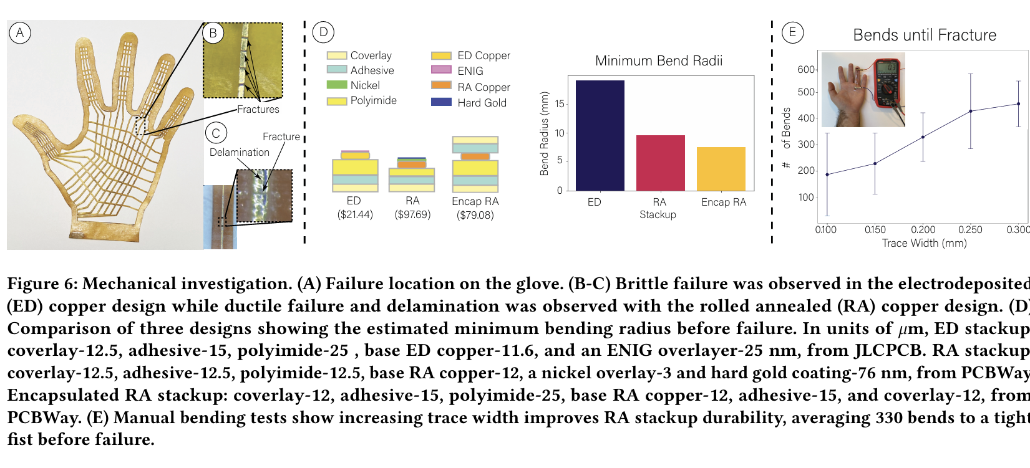
Figure 6: https://dl.acm.org/doi/epdf/10.1145/3706599.3720147

Generally, a recommendation of settings is given in the documentations page: https://wiresens-gloves.vercel.app/assets/large_pcb_top_details.pdf.

  - How do I then do a custom geometry for other body pads?
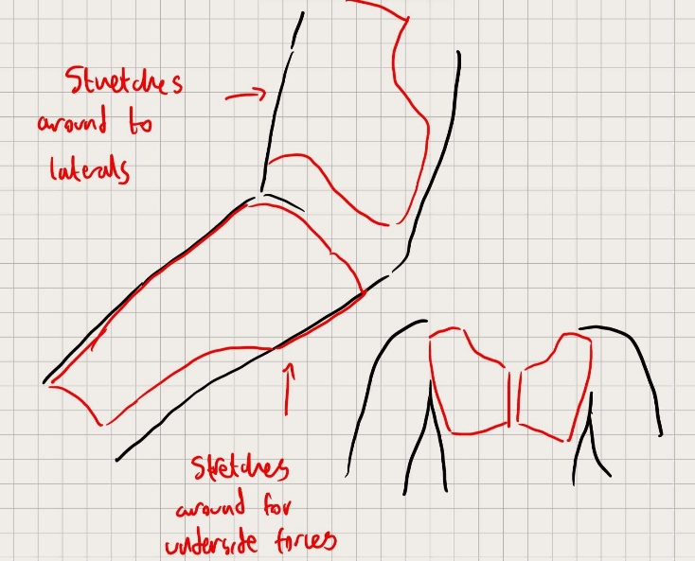
Figure 7: quick sketch up of the geometry of the bicep pads.

Image above: shows a rough sketch to visualise the approximate geometries of the pads that would be used for the forearms, biceps and chest.
The bit being skipped from make_fpcbs.ipynb is all the image detection and automatic geometry detection, contour generation etc…
This is ‘fully’ composed from some custom geometry estimations using a python script:
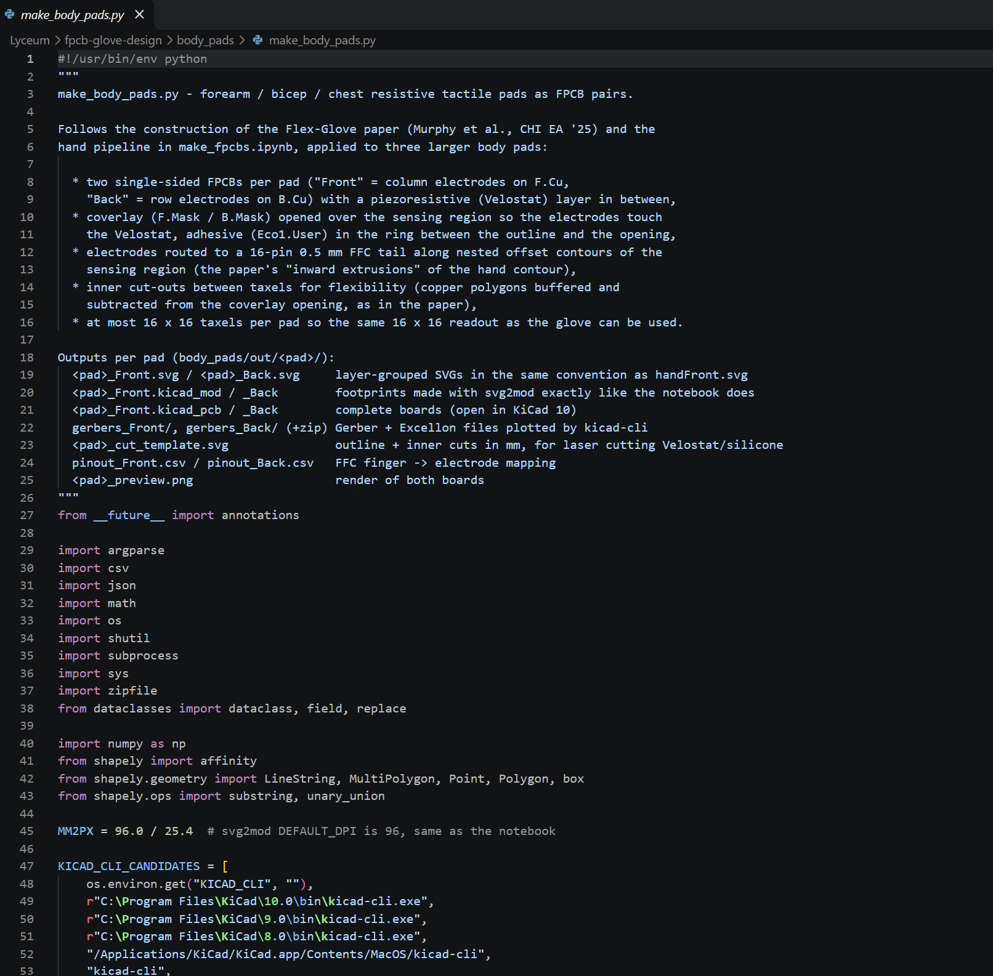
Figure 8: Snippet from the new body_pads branch for generation of the initial set of body pads. Script called: make_body_pads.ipynb
The script generates the matrix of pressure points for sensing, where the back and front copper tracks will overlap and overlay. This then generates the SVG, which feeds into the same KiCAD gerber generator for the design file. For example, see the left chest pad render below:
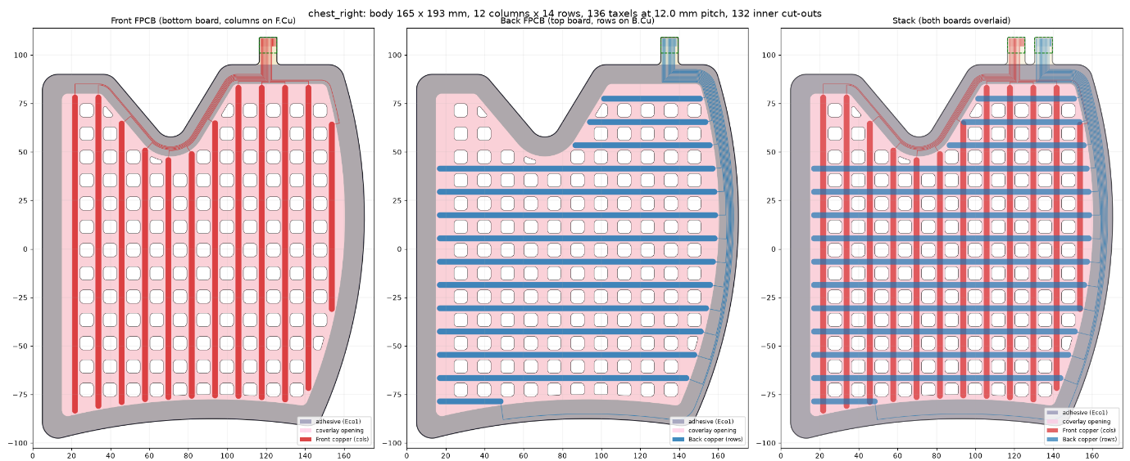
Figure 9: render shows front copper, back copper, and the overlayed geometry for the pressure sensing points.
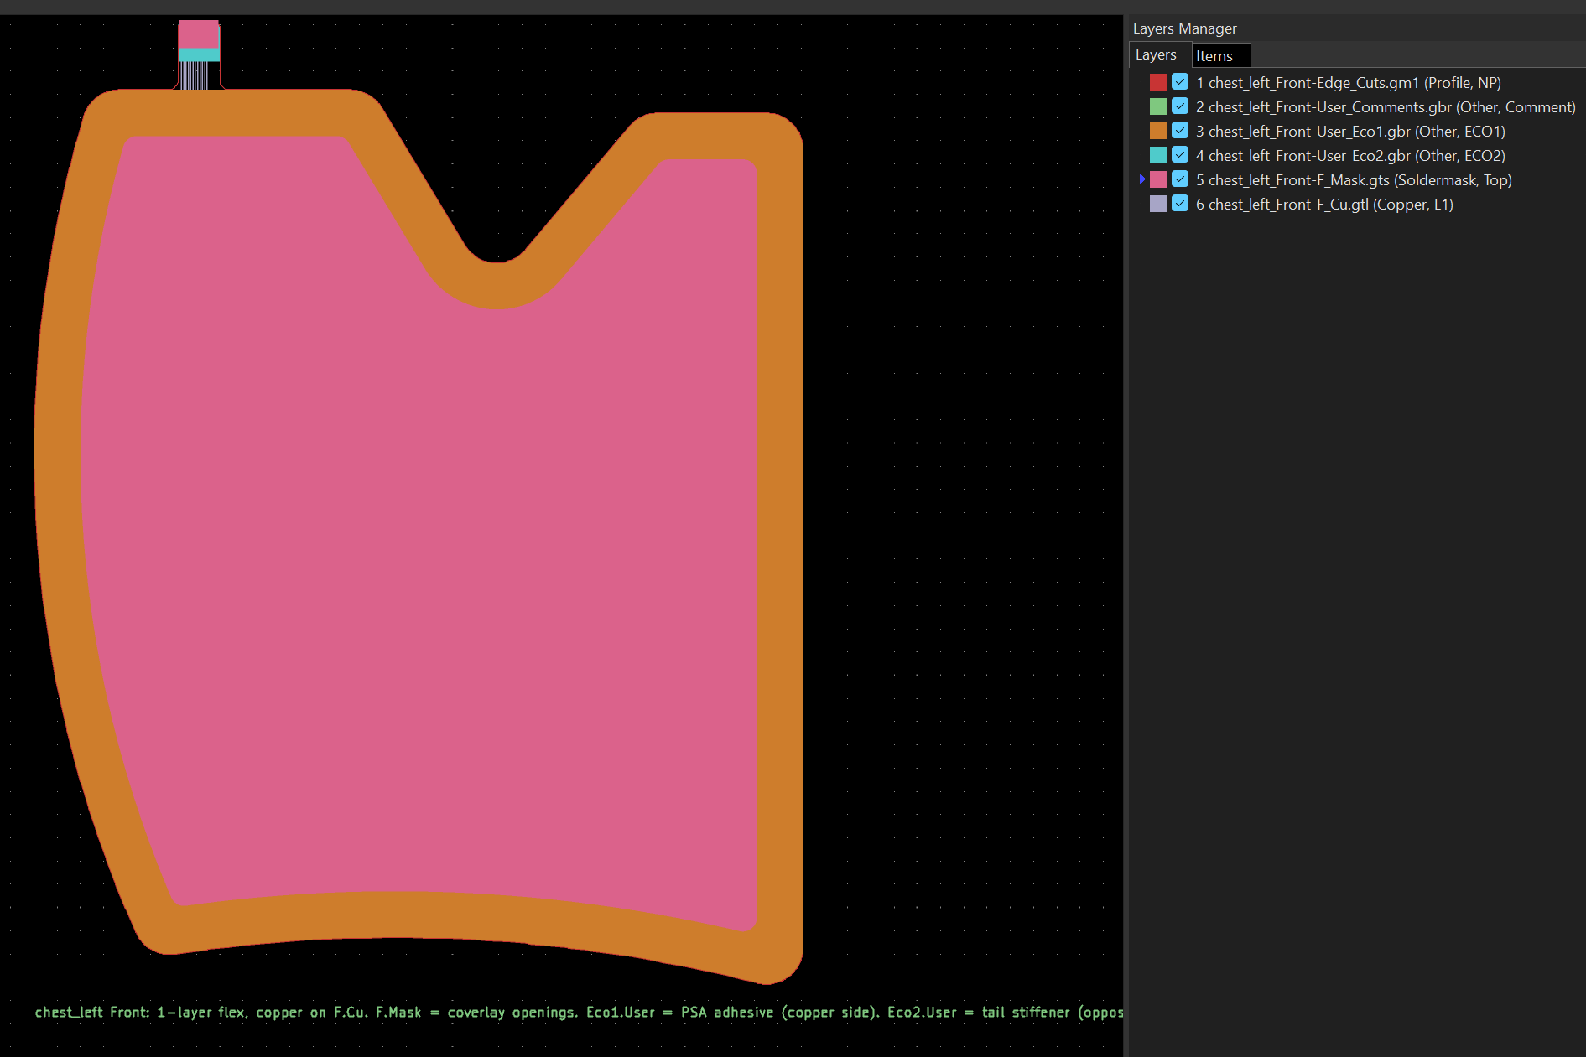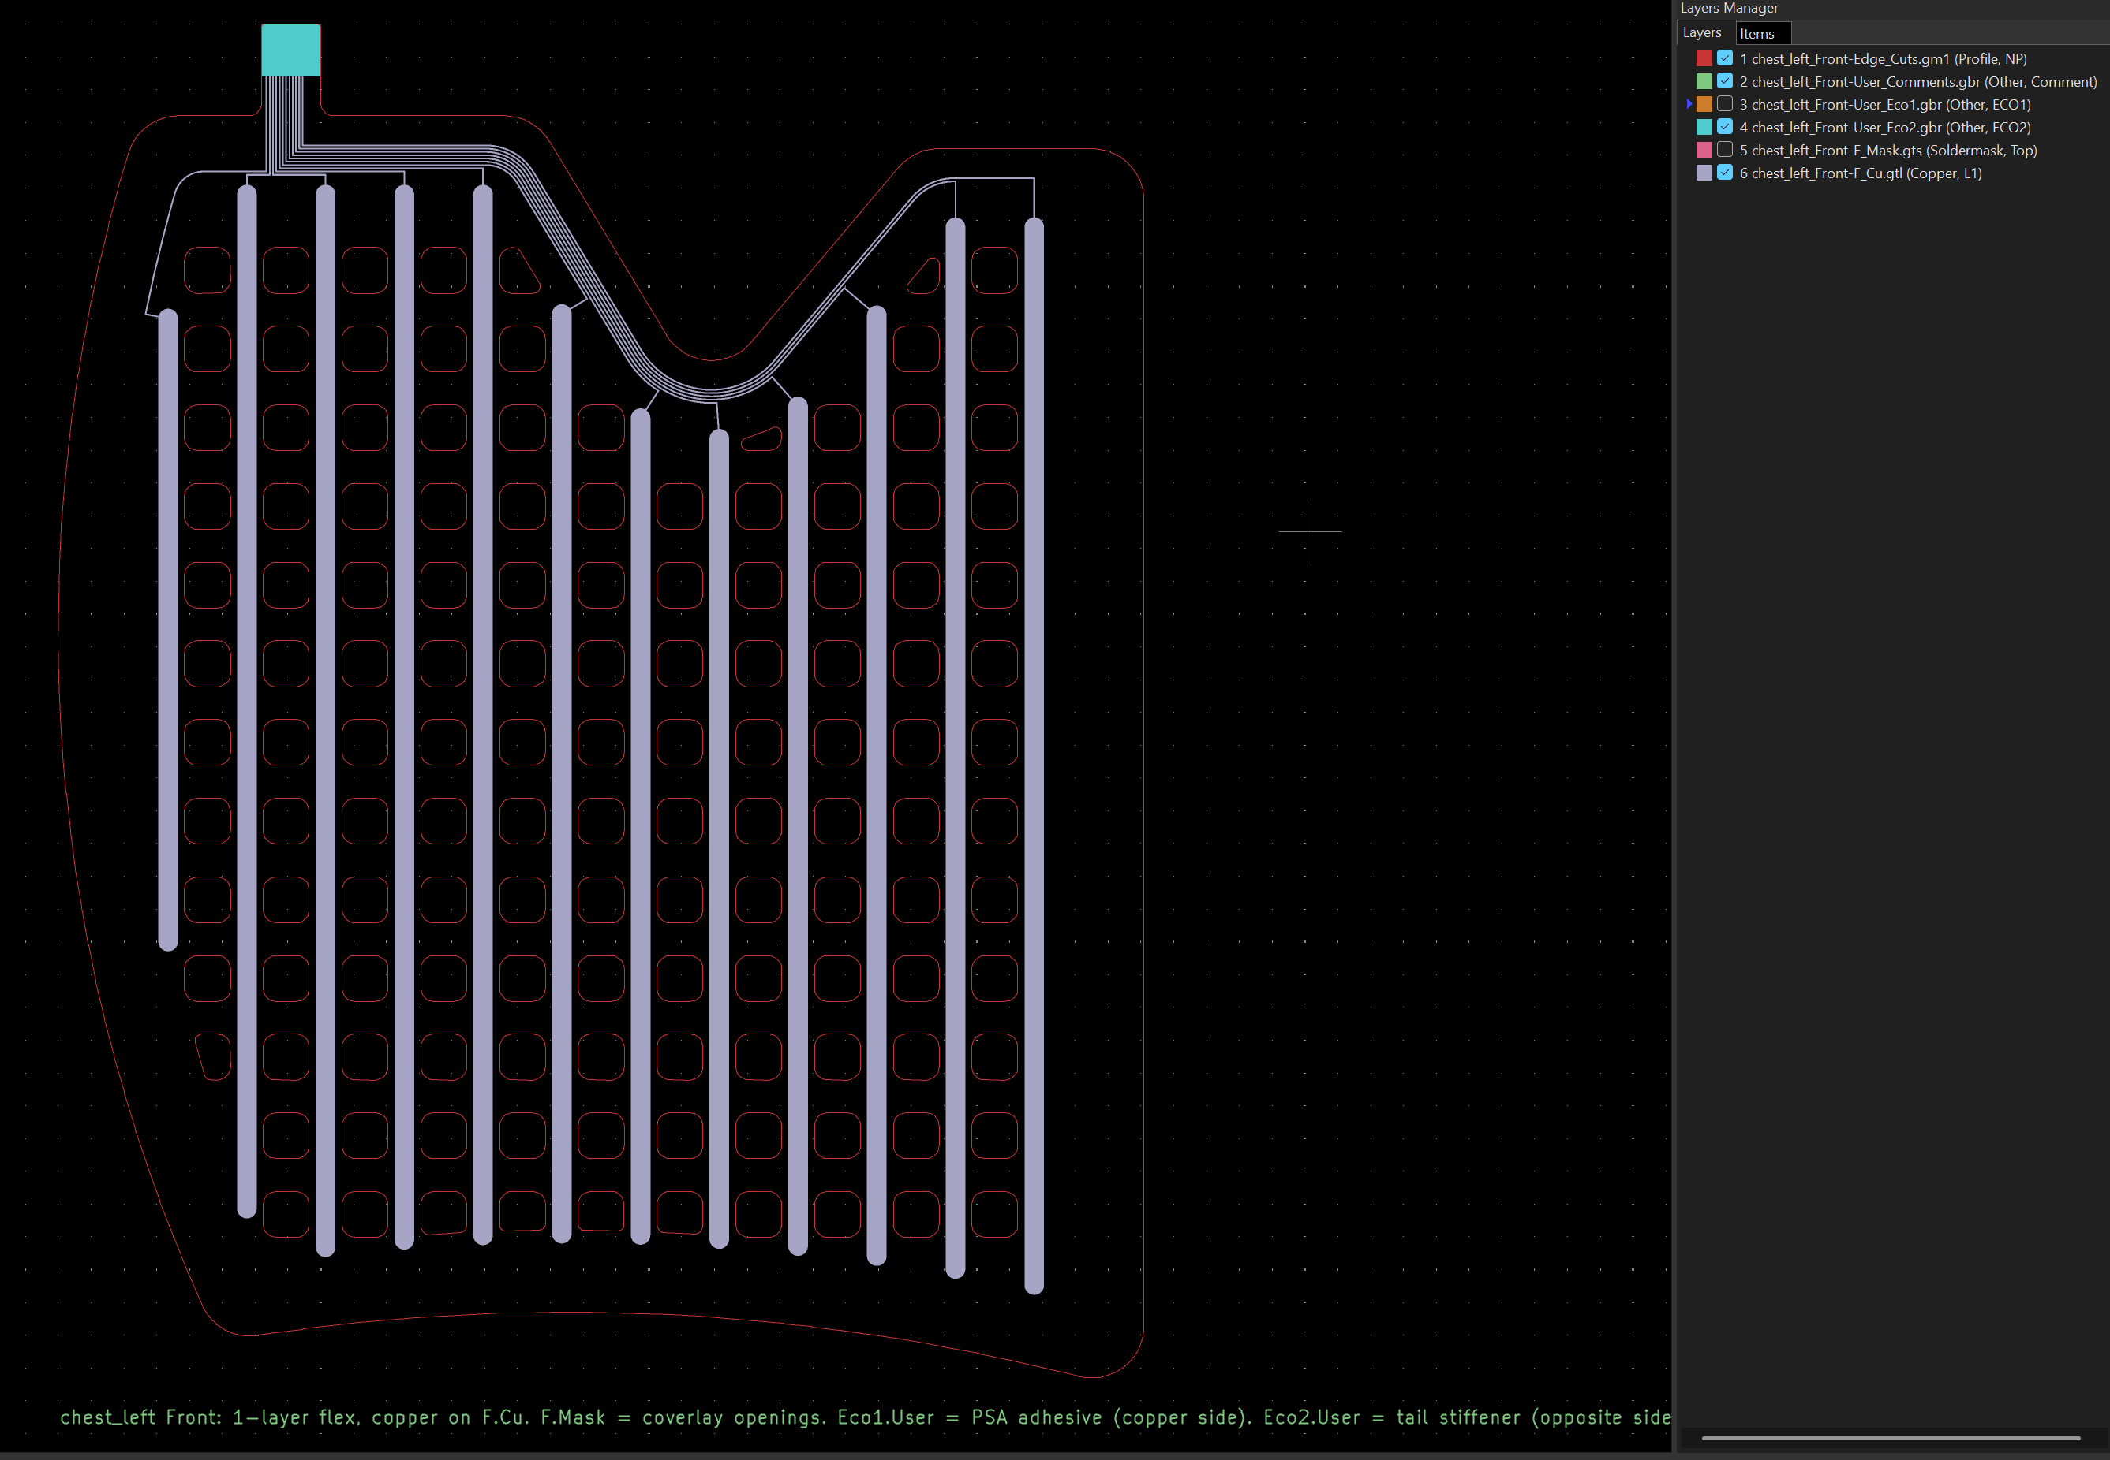
Figure 10: KiCAd Gerber viewer views – left shows the entire file with mask and edge adhesive poliimide, while the right is shows in the detail the routing of the copper tracks on the bottom board of the chest pad.
 | Iteration 1 | Iteration 2
Bicep | 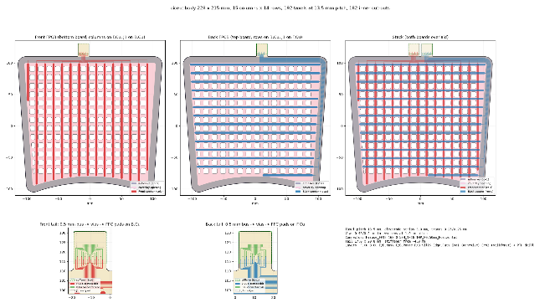
Chest
Forearm | 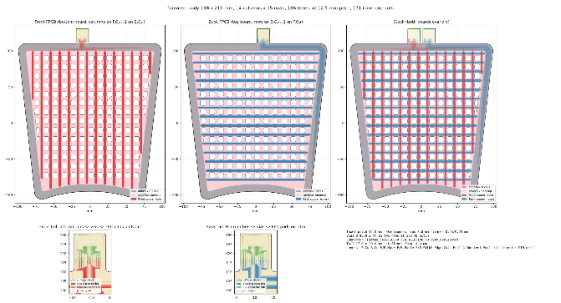
Issues

  - What are the other layers that I need and how do I make them?
Velostat, fabrixc layer? Adhesive?
Cut out paper for the exact geometries, then show iteration 2 – show iteration 1, then iteration 2

